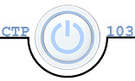

# CTP 103 Course Project Part 3 – RESEARCH and Microsoft Word Outline – 50 points

##### Overview

In this part of the project you will do academic research on the topic you chose, build your bibliography, and create an outline in Microsoft Word.

##### Section I – Conducting Research

You will begin this section by conducting scholarly research on the topic you chose for your research paper. This means you will need to use the AACC Library Databases and Google Scholar, not simply a Google search. The point here is that you will need to have a PDF copy of an article from a periodical or journal that has an author and a date. Again, ALL your articles MUST have an author and a date. You will need to have a minimum of four articles and they need to be within the last seven years. You may have ONE article that is from a website, but it must have an author and a date and must be referenced correctly in your bibliography. See the links to the videos below to get started. Note: our librarians at AACC are a great resource to assist you.

How to use Google Scholar:

* <https://www.youtube.com/watch?v=yDbghsm_d6Q>
* <https://www.youtube.com/watch?v=aTi7EnN_kRI>

How to use the AACC Library from Off Campus (you need your student ID)

* <https://www.youtube.com/watch?v=u1C-amc7EUw>
* [https://www.youtube.com/watch?v=11Micq8vlzk](https://www.youtube.com/watch?v=11Micq8vlzk )

##### Section II – Creating an Outline in Microsoft Word – 20 Points

Studies show that creating an outline makes writing a paper easier and improves grades. Microsoft Word has an outline tool that you will use to organize your paper.

The idea of creating an outline before you write your paper is to give your paper a logical structure. In this outline, you may use a topic “bullet-type” statement or ONE sentence. You may have no more that ONE sentence for each level in the outline. Since you will be using the Word outline tool, you will NOT use an alpha-numeric structure to the outline. The Word Outline tool uses “Levels” or Headings to indicate the level in the outline (instead of Roman numerals. Here is a video on how to use the outline tool in Microsoft Word: <https://youtu.be/swswieog5Os>.

Use [this basic guideline](http://www.crestmont.edu/pdf/candidates-reserarch-papers.pdf) (this is a PDF document) for writing your outline. You will not write your introduction or conclusion, but you will include a thesis/topic statement.). [Walden University](https://academicguides.waldenu.edu/writingcenter/writingprocess/outlining) also has a good article for outlining strategies.

To begin, double-click in the header of the document and type your first and last name. Enter the title of your paper centered on the first line and then proceed with your outline. Your completed outline will look like this:

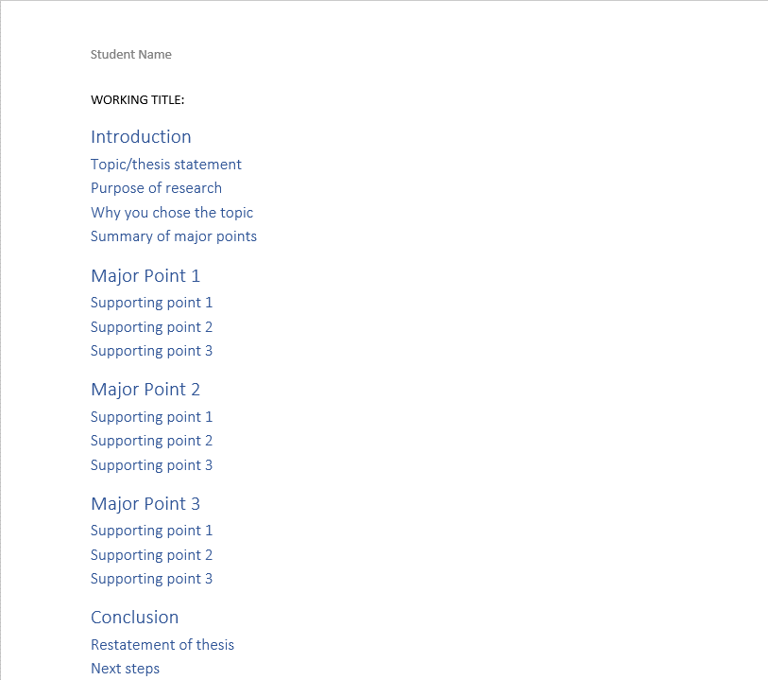

Note: The Word default template is not formatted according to APA guidelines. You will do that in the next step of the project.

After you have completed your outline, save the document as **LastName_Outline.docx**

##### Section III– Creating a Bibliography in Microsoft Word – 20 Points

In this section, you will use Manage Sources in the Citations & Bibliography group on the References tab in Microsoft Word to add a bibliography to your outline. **You will use the APA, Sixth Edition style guide.**

Select APA from the References tab in the Citations & Bibliography group:

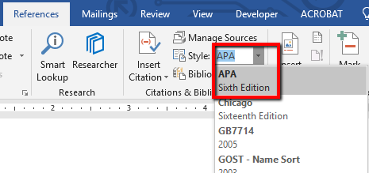

Watch [this video](https://www.youtube.com/watch?v=TxLuuNprjXg#t=1h22m47s) to learn how to use the Microsoft Word bibliography tool. (Note: this video is a comprehensive video for Word 2016 that is two hours long. However, the video is queued to the correct spot to start at the spot he explains how to use the bibliography tool. It is at 1 hr, 22 min, 47 sec.)

After you have watched the video, open your **LastName_Outline.docx** document and perform the following tasks.

1. Go to **Manage Sources** on the **References** tab in Word and add all the sources you collected in your research.
2. At the end of the outline, enter a page break (using CTRL+ENTER or go to the **Layout** tab and click on the **Breaks** dropdown and select **Page** – *do NOT hit the ENTER key multiple times to get to the end of the page****.***)
3. Insert the bibliography as References (according to APA Sixth Edition) using the Bibliography dropdown on the References tab.

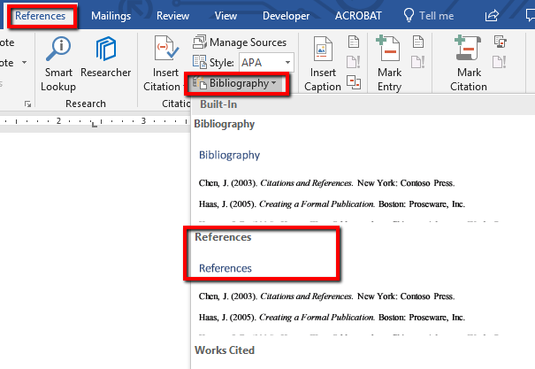

1. Save the outline document.

**You will not format the bibliography until your research paper is completed in Part 4.**

Note: if you do not use the Word Reference Tool for your Reference sources, you will not get credit for the References page.

##### Submission Instructions

Submit the **LastName_Outline.docx** to the dropbox in Canvas by the due date.